Meet our Catechists

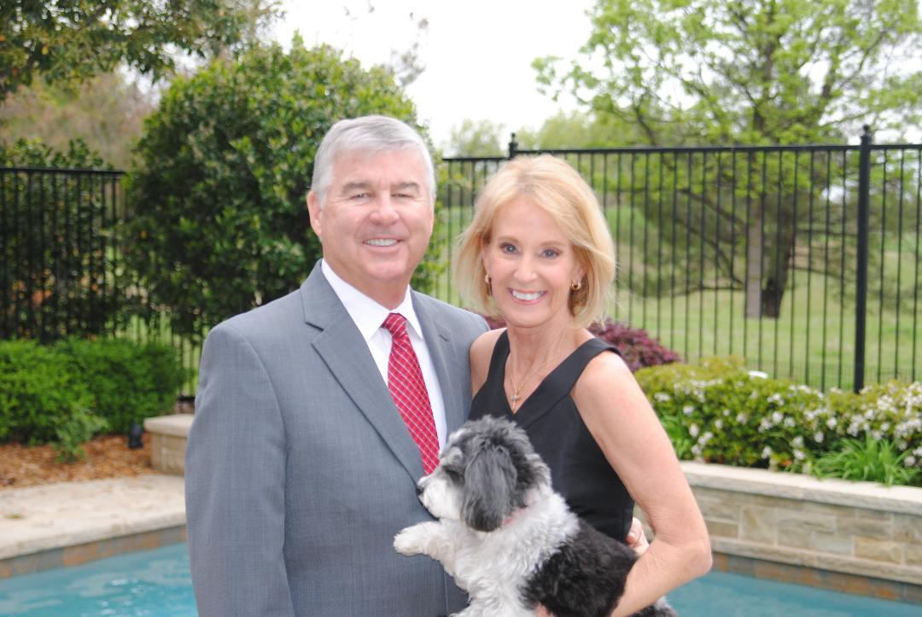

Linda Kelly
I have been a member of Prince of Peace Catholic Community for 15 years. I completed the POP RCIA program in 2008 and received my First Communion at the Easter vigil. The RCIA program enriched my faith and made me proud to be a Catholic. My service to the parish has been as the Lay Director for Christ Renews His Parish as a travel team of ladies introduced the program to a parish in Colleyville. I currently chair the Discipleship Committee and chair the Kids Helping Kids program. Each quarter, Prince of Peace Catholic Community, Discipleship Committee, contributes to community projects through the Kids Helping Kids basket donations. We believe an important part of our mission is to make our community a thriving place for all to live, work and pray. I am married to Ed Kelly. We have 12 grandchildren and a very cuddly MaltiPoo, Buddie. We live in Frisco, Texas. One of my greatest joys is to work with children and feel very blessed to serve as one of the teachers for KidCat.
Contact Information: 972-742-0007
mimilindakelly@gmail.com

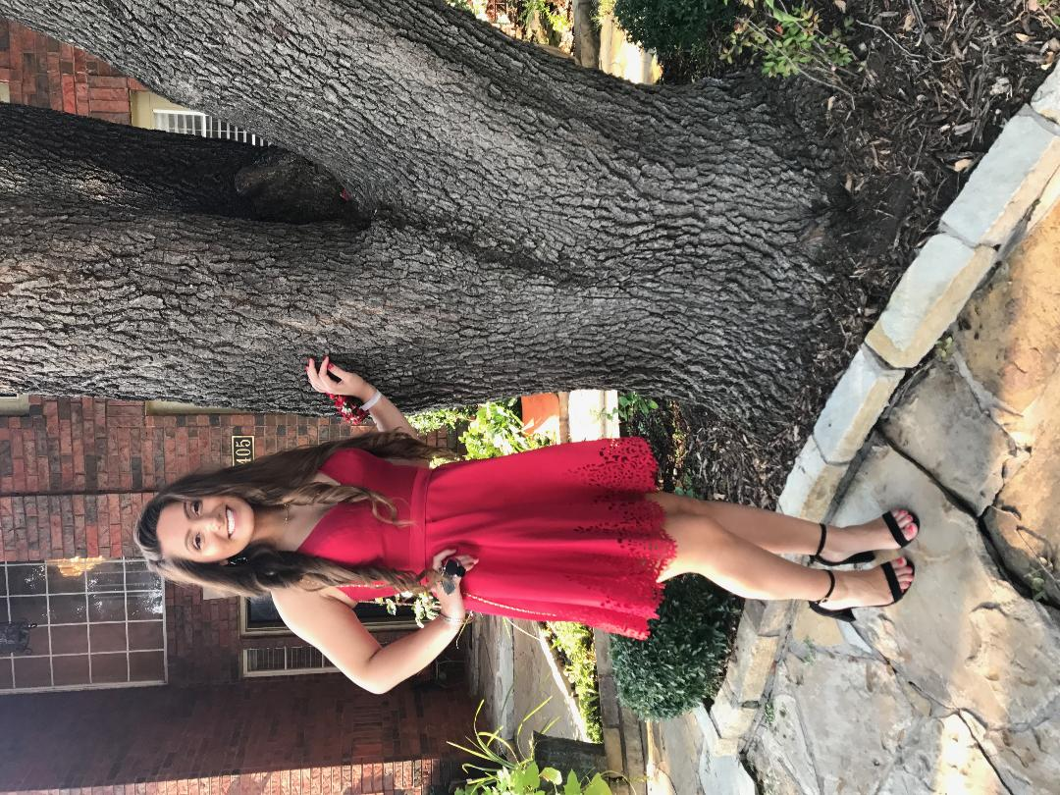

Kelsey Carolyn Taft
I was born in Chicago, Illinois, and moved to Plano, Texas in 2001 when I was six months old. I am currently a sophomore at Jasper High School in Plano taking general studies. I plan on majoring in Aerodynamics Engineering and work with the NASA team here in the United States.
There are many things I enjoy doing on my free time, one of which is playing my piano at home. I enjoy being able to read and understand the language of music and be able to express myself through music. I am also a member of the Varsity Mixed Choir and select choir “Harmony” at my school.
I enjoy sports, especially basketball. I am very honored to be part of the girls’ basketball team at my school. Being part of such a hard working team provides me with a profound feeling of achievement and accomplishment, but most importantly, I take pride in belonging to a group of young ladies who are hardworking, focused, and dedicated.
One thing I enjoy the most is knowing I belong to a wonderful, caring, and community focused parish, “Prince of Peace.” My family and I became members of the parish in early 2014. I recall when I first entered the parish I felt a sense of belonging and a sense of peace. I was honored to know I would be preparing for my First Holy Communion and Confirmation at the parish. I entered the KidCat program with some hesitation, but once I was welcomed with open arms I knew this was where I needed to be. I was confirmed and received my First Holy Communion during the Easter Vigil in 2015. It is a day I hold close to my heart. It is a day I received the body and blood of Christ for the first time. It is a day I will cherish and remember for the rest of my life.
My goal is to share these feelings of belonging and community with the new incoming KidCat students. I want to help educate them on why we are not number one, not number two, but number three.
Contact information 972-322-6860
taft.kelsey@gmail.com

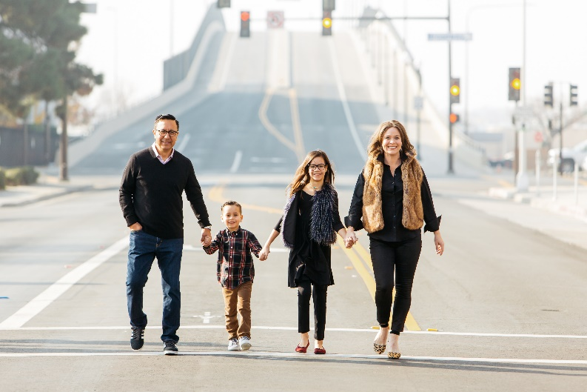
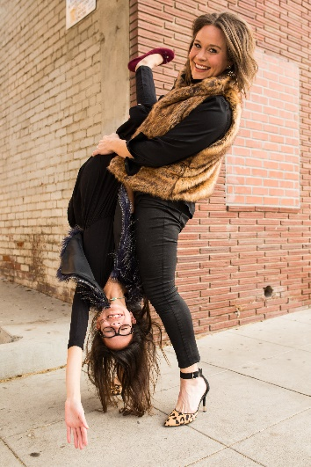

Allison Talamantez

POP is a place that makes me feel like I am at “home”. I was raised Methodist and converted to Catholicism at St. Leo the Great in Oakland, CA where I had my confirmation and first communion at the Easter Vigil in 2005. My husband and I were married by Monsignor Peterson that following August in Fresno, CA. My Catholic faith is something I deeply cherish and is at the root of so many relationships that are the most meaningful in my life. We joined POP as a family immediately upon moving to Texas from California in 2012. From the start Prince of Peace was family- as my brother, sister-in-law, and niece joined in 2011 after they were baptized, confirmed, and had first communion at Easter Vigil. Since then we have made friends in the parish that we consider family. Being involved in various ministries in the parish has allowed us to grow in our love for the community as a whole- from Gia participating in KidCat to CRHP to lectoring and everything in between POP touches and enriches our lives!

Contact Information: 469-557-1118

allison.talamantez@gmail.com

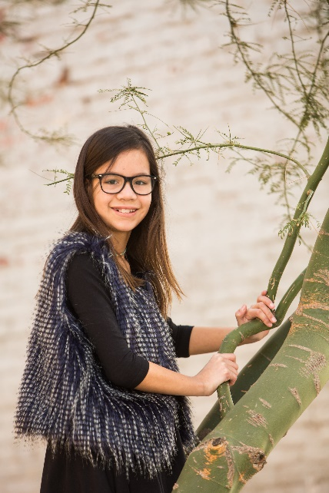

Gia Talamantez
(Teen Helper)

I loved participating in KidCat at POP in 2015 and taking my first communion and confirmation at the Easter Vigil of 2016. My family started attending POP in August of 2012 when we moved here from California- where I was born! I am in 5th grade at Isbell Elementary. In my free time I sing in the choir, ride my bike, and I am part of the Girl Scout troop here at Prince of Peace. I am very excited to be part of KidCat- I hope you enjoy it as much as I did!

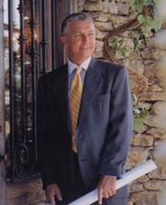

Steve Trumbly
My name is Steve Trumbly. I'm a retired lifelong home builder from Oklahoma City and currently do some residential Architectural Design from home. I moved to Plano last year to be close to my beloved Corryn 12 and his sister Carolyn 11. Both Corryn and Carolyn completed the KidCat program recently and were Baptized into our Catholic community on the 31st of March 2018. As for myself I was Baptized into the Catholic faith in 1999 at the St. Joseph's Old Cathedral in Oklahoma City. The church was completed in 1904 and sustained extensive damage in the Alfred P. Murrah Federal Building bombing on April 19 1995 which was located across the street from the church. Due to the historic value of the church it underwent a lengthy and very careful rebuilding process. Upon moving to Plano Corryn, Carolyn and myself visited several Catholic Churches. I told both Corryn & Carolyn that I would let them pick the one that we would join and attend. When we visited Prince of Peace they immediately told me that this was where they want to attend & belong and I couldn't have agreed more or been happier with their choice. We love to help and volunteer whenever needed. Corryn is very involved in our Boy Scout Troop at POP and Carolyn is equally involved in our 5th grade Girl Scout Troop as well. Both are looking forward to being involved in our Youth Ministry Group as well as myself in Knights of Columbus.
I look forward to teaching in the KidCat program and meeting each of you.
Contact Information 405 642-4863
sdtrumbly@gmail.com website http://stevetrumbly.com/
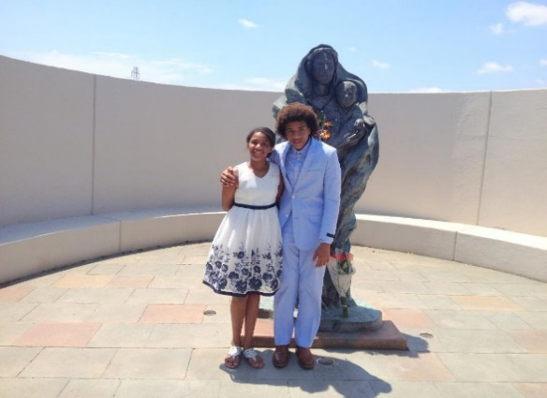

Carolyn Kidd

Carolyn and Corryn Kidd
(Teen Helpers)

(Carolyn) I enjoyed participating in KidCat at POP last year. I was initiated this past year at the Easter vigil so I have much to share with our class. I enjoy being part of the POP community. I sing in the children’s choir and am a member of the POP Girl Scout Troop to name a few. I will be entering 6th grade at Frankford Middle School this fall.
My passions are singing both in and out of the choir and writing musical lyrics. I enjoy watching movies about the 1800's as well as the movies made since the 90’s and cherish many early childhood friendships.
I look forward to walking the pathway to the Easter Vigil with new friends at POP.

(Corryn) I really enjoyed participating in KidCat at POP last year. I was initiated at the Easter Vigil and will have many things to share with our class. I enjoy being active in our POP community and volunteer on a regular basis. I'm also very active in our POP Boy Scout Troop and take my Catholic faith and being a Boy Scout seriously in being the person I hope to be. I will be entering 8th grade at Frankford Middle School this fall and science is my favorite subject. My passions are playing sports, scouting, our POP community, science and the many friends that I've been blessed to make. I'm looking forward to assisting in the pathway to the Easter Vigil and attending with new friends.

